# Chrome_TC_03:Sales_Invoice_Creation

### Orient LED Login Page.

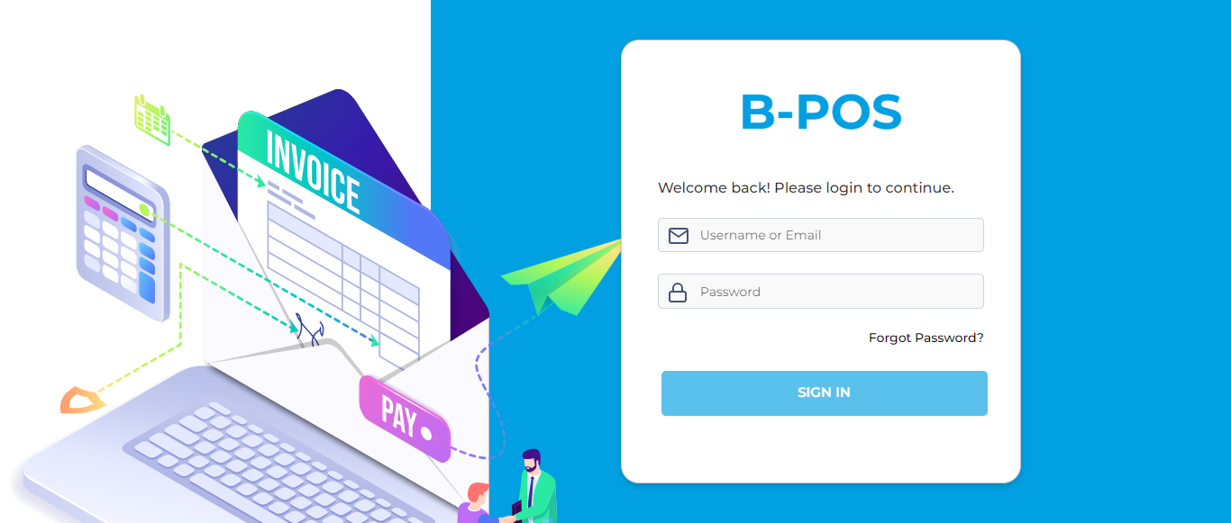

### The Home page with lot of navigation options to navigate different modules and serving as the entry point to the website.

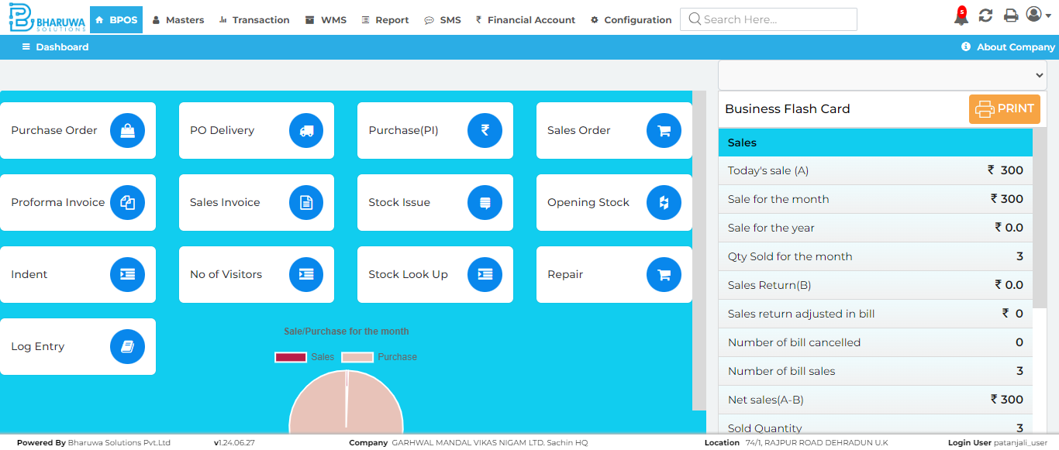

### Transaction module with lot of sub-modules to perform vairous transactinos for user.

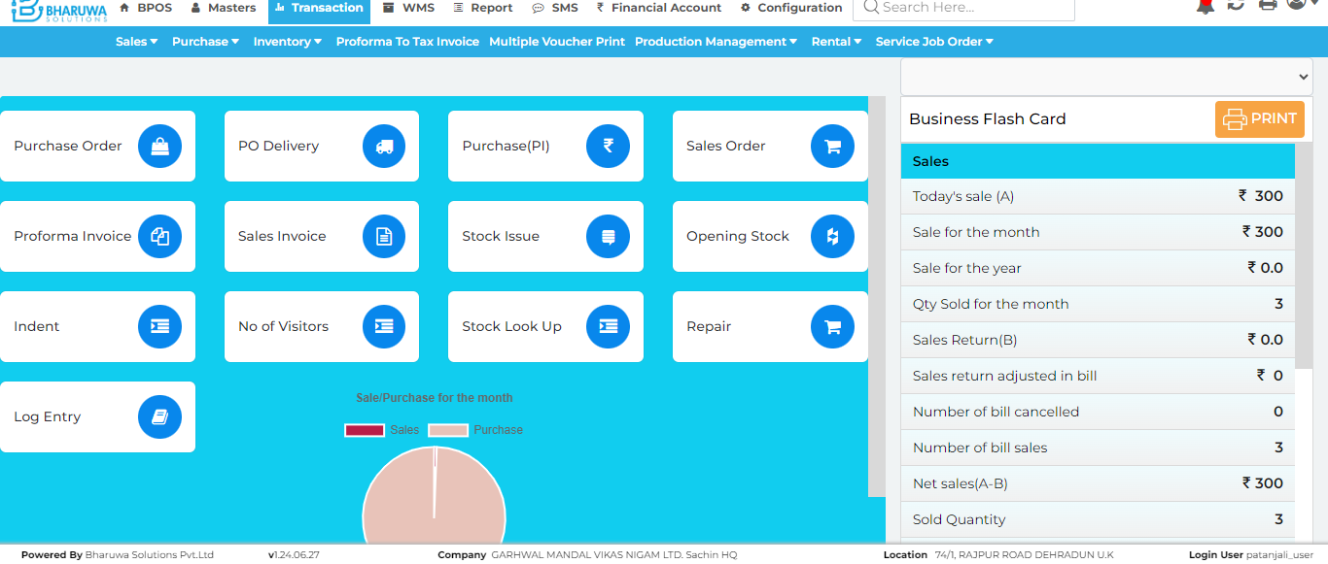

### Sales invoice page, The sales invoice screen is where sales transactions are recorded and processed.

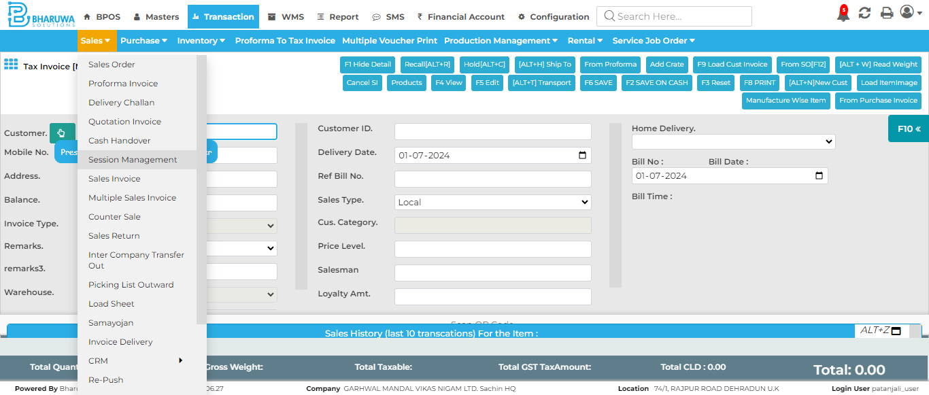

### Successfully created sales invoice for specified product with unbatched batch of items.

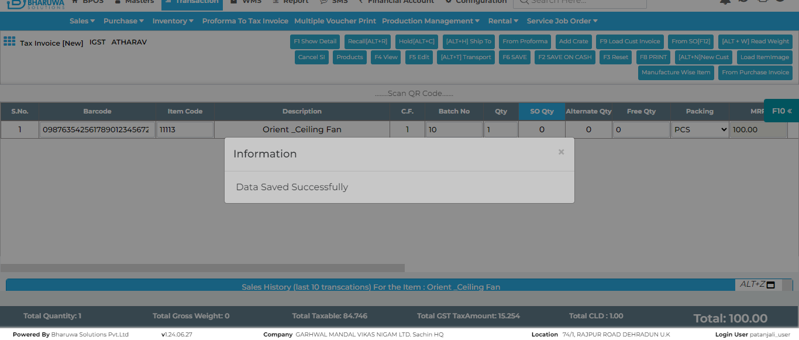

#### TC_03 - TEST PASSED